Clear equipments p14-

Clearing tank

Acid/alkali-base treatment tank

Organic treatment tank

Washing tank

Ion free water

Lithography

Definition

pattern copying (and etching) for precise surface finishing

Objective (purpose)

Transfer the pattern of the mask into the device structure on the substrate, thereby realizing the selective diffusion and metal thin film wiring

basic components

exposure light source

optical system

support positioning platform

Track system

Inspection and metrology tool

(Main material)

Mask

Resist

developer

basic steps

1. Wafer treatment
2. Spin coating
3. Soft baking
4. alignment and exposure
5. Post Exposure Baking
6. Development
7. Hard baking
8. Check
9. Etching
10. Strip photoresist

basic requirements (performance indicators)

Resolution

Setting accuracy (registration)

the statistical measurement of alignment error between layers, which mainly depends on the graphical positioning of lithography system and the control accuracy of the supporting platform

Yield (throughput)

Machining on large size silicon wafer

Low defect.

乱 跳过(pdf p50-81)

Micro-lithography Key parameter p50

Opticis

Resolution

Exposure Latitude

Depth of Focus(DOF)

Chemistry

Aspect Ratio

Resist film loss

Theory of Scanning Electron Microscope p53

RET (Resolution Enhancement Technology)

OAI, PSM, OPC…

Tool induced shift TIS p76

is a metrology error characteristic to any metrology tool.

chemical-mechanical planarization CMP

Mask Introduction p82-89

Pitch: Line Width + Space Width

Shot: scanner/stepper standard exposure filed

Die : minimum effective circuit chip

Photoresist p90-p106

Functions:

Undergoes a photosensitive reaction and changes its solubility in a developer to form the specified pattern and protect the substrate during etching

Composition (component materials)

Resin (the matrix material)

Resins are an inert（惰性）polymers, including carbon, hydrogen, oxygen

Resin serves as a binder, and establishes the mechanical properties of the film.

Sensitizer (photoactive compound PAC)

allow a chemical reaction by light energy. After adding a specific sensitizer, the sensitivity to a specific wavelength increases and the spectral range of the reaction light is limited

Solvent

The largest component of the photoresist is the solvent.

Keeps the resist in a liquid state untill it is been applied to the substrate being processed.

With the polymer dissolved in the solvent a thin photoresist film can be obtained by spin coating.

The solvent has little effect on the photochemical properties of the photoresist

the vast majority of the solvent can vaporize before UV exposure

Additive (optional)

change the specific chemical properties or photoreaction properties of photoresist.

Typical additives are dies（晶粒？） to reduce reflection and catalysts to control or accelerate reactions.

Comparison of negative and positive photoresist

|  |  |
| --- | --- |
| negative photoresist | positive photoresist |
| from solubility to insolubility (photosensitive cross linker) | from insolubility to solubility (hydrophobic sensitizer) |
| disadvantages | advantages |
| Swells during develop | No swelling during develop |
| marginal step coverage边缘步骤覆盖 | good step coverage良好的步覆盖 |
| organic solvent developer | aqueous developer |
| toxic strippers有毒的剥离器 | environmentally benign resist stripper环保型抗剥离剂 |
| sensitive to ambient oxygen | operates well in air |
| advantages | disadvantages |
| excellent corrosion resistance. | Poor corrosion resistance |

Detail Litho Step p107-

Wafer treatment 109

To ensure that the photoresist can be well bonded to the surface of the crystal bed

Three steps

particle removal

Dehydration 脱水

Primer 底漆 (salinization碱性化)

form hydrophobic surface

Spin Coating

steps

1. Flooding the substrate with resist solution.

2. Accelerating to a desired rotational speed.

3. Spinning at a constant speed to near dryness.

4. Removing the edge bead.

Temperature

Too low temperature --> Dished profile (low in center)

Too high temperature --> Domed profile (high in center)

Soft-bake

Purpose

Remove solvent

Control resist sensitivity and linewidth (什么意思)

Stress release

Post Exposure Bake

Purpose

Average out standing waves in the resist latent （潜在的）image.

Activate chemical amplification in the CAR system. （？）

PR Developing

Developer is very strong alkaline water solution

Litho Optics p125

NA: higher NA can better resolve two features that are laterally and vertically close

DOF p135: the range of focus that still keeps the shape with a tolerable error

Factors that affect exposure quality

1. Factors the affect Image resolution (Aerial Image Contrast)

Increase NA

Decrease wavelength

Increase coherence

off axis illumination

Indicators

Normalized Image Log Slope (NILS)

NILS is the best single merit to judge the lithography usefulness of an aerial image

Modulation Transfer Function(MTF)

1. Factors the affect contrast and DOF

find best combination of NA, coherence, oblique angle for given feature (Trade off of Resolution and DOF)

MEF control with defocus and dose error (fine control needed) (?)

1. Others

The thickness uniformity of the photoresist

standing wave

Mask Error Factor ( MEF ) p154 没懂

Factors that influence MEF

Don't understand

Implications

Different type of OAI

NA optimize

Wavelength decrease coherence increase NA

Lens Aberration p159

5 common aberrations

Spherical aberration, field curvature , distortion , astigmatism ,coma

impact of aberrations

All aberrations

Reduction of contrast

Even aberrations

Axial image shift

Odd aberrations

Lateral image shift

Optical Process Error p185-p192 (空)

Etching p194

Requirements p197

directionality

selectivity (etching selection ratio)(the higher the better)

Uniformity ( in slice, slice to slice, batch to batch 这语法不知道对不对)

Etching rate

Cleanliness

Minimal damage to surface

Etching profile（无明确指向）

Dry etching and wet etching

Wet Etching: substrates are immersed in a reactive solution. The layer to be etched is removed by chemical reaction or by dissolution. The reaction products must be soluble and are carried away by the etchant solution

Dry etching: Substrates are immersed in a reactive gas (plasma).The layer to be etched is removed by chemical reactions and/or physical means (ion bombardment).The reaction products must be volatile（挥发性） and are carried away in the gas stream. Dry etching is the main method of etching the sub-micron size.

|  |  |  |
| --- | --- | --- |
|  | advantages | disadvantages |
| Wet etching | * 1. wide range of applications, suitable for almost all materials   2. selective strong   3. simple equipment, low cost, good repeatability, suitable for high-volume processing, high efficiency   4. no plasma damage | * 1. isotropic corrosion   2. Poor resolution   3. Unecnomical (requires a large number of corrosive chemical reagents and deionized water)   4. creating pollutants.harmful to the human body and the environment   5. uneven corrosion (the chemical reactions often release heat and gas) |
| Dry etching | * 1. Anisotropic   2. high resolution   3. Clean, safe and economical | * 1. damage to surface and circuit   2. the equipment is complex |

classification of dry etching

Metal etching

In the metal layer to remove the aluminum alloy composite layer(铝合金复合层), to produce the Internet

Dielectric etching

For dielectric materials such as silicon dioxide, silicon nitride

Silicon etching

Including the etching of polysilicon. Used in the removal of silicon, such as etching the polysilicon transistor gate and silicon cell capacitance

graphic etching

no graphic etching

STI silicon nitride stripping

Physical etching, chemical etching, physical and chemical etching.

popular etchants and etching gases p225-p233

|  |  |  |
| --- | --- | --- |
| silicon dioxide | ${NH}_{4}F$ (40%): HF(40%)=7:1 |  |
| silicon nitride | $H_{3}{PO}_{4}$ (85%) |  |
| silicon | KOH(3%~50%) or HF(49%):HNO3(65%):CH3COOH(100%)=2:15:5 |  |
| aluminum | $H_{3}{PO}_{4}$ (85%):HN $O_{3}$ (65%):C $H_{3}COOH$ (100%): $H_{2}ONH_{4}F$ (40%)=76:3:15:5:0.01 |  |

Others

Advanced exposure light source

Requirements

The exposure light source must be stable, reliable, of high intensity, and long in life.

Exposure light source are High pressure mercury lamp and Excimer lasers.

|  |  |  |
| --- | --- | --- |
| High pressure mercury lamp | g-line | 436 |
|  | i-line | 365 |
| Excimer laser | KrF | 248 |
|  | ArF | 193 |
| Laser-produced plasma  (LPP) or  discharge-produced  plasma (DPP) | Extreme ultraviolet (EUV) | 13.5 |

Next generation exposure light source are X-ray, Electron beam and Ion beam.

Supplementary from website

Resolution Enhancement Techniques (RET)

off-axis illumination (OAI)

immersion lithography

optical proximity correction (OPC)

phase shift masks (PSM)

Other questions

What is the standing wave effect? How to reduce the standing wave effect?

Interference between incident and reflected light causes excessive exposure and under exposure in the sidewall which Influence the photoresist resolution.

Anti Reflection Coating (ARC) Post-exposure baking (PEB)

Why only one wavelength selected from the Mercury lamp and how to select?

What are the two graphs?

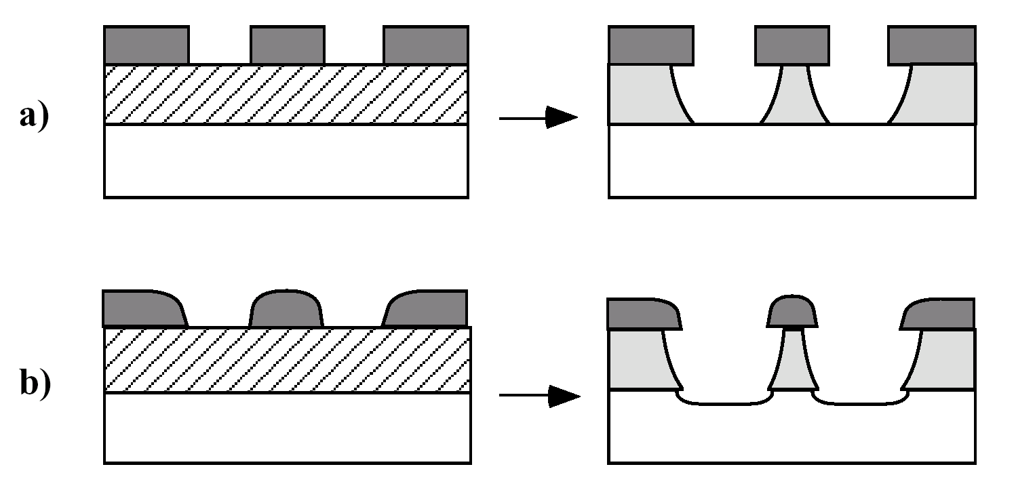

1. A lateral etching under the mask. The etching directionality is not good.
2. Photoresist and the lower layer are also significantly etched, and the rounded photoresist leads to more lateral etching. The etching selectivity is not good

What are the three types of dry etching What are the principles and characteristics of each?

Why is a 4:1 shrink ratio more popular in the semiconductor industry than a 10:1 shrink ratio?

Choosing between a 4:1 shrink ratio and a 10:1 shrink ratio involves

a tradeoff between resolution and throughput. Obviously, 10:1 image

shrinking will have better photolithography resolution than 4:1 image

shrinking; however, it only exposes 16% of the area that is exposed by a

4:1 shrink ratio for a reticle. This means that total exposure time will be

6.25 times longer.

What are the exposure methods?

a. Contact printing; b. Proximity printing; c. projection printing

Why only one wavelength selected from the Mercury lamb and how to select?

the spectral range of the photoresist is limited after adding a specific sensitizer and we need to select from the utilization of sensitizer.

What are the three types of dry etching What are the principles and characteristics of each?